Business Unit:  - Flat-backs  - Skinks  - Sea snakes  - Gold bandicoots  - Euro  - Oyster catchers |  |  | 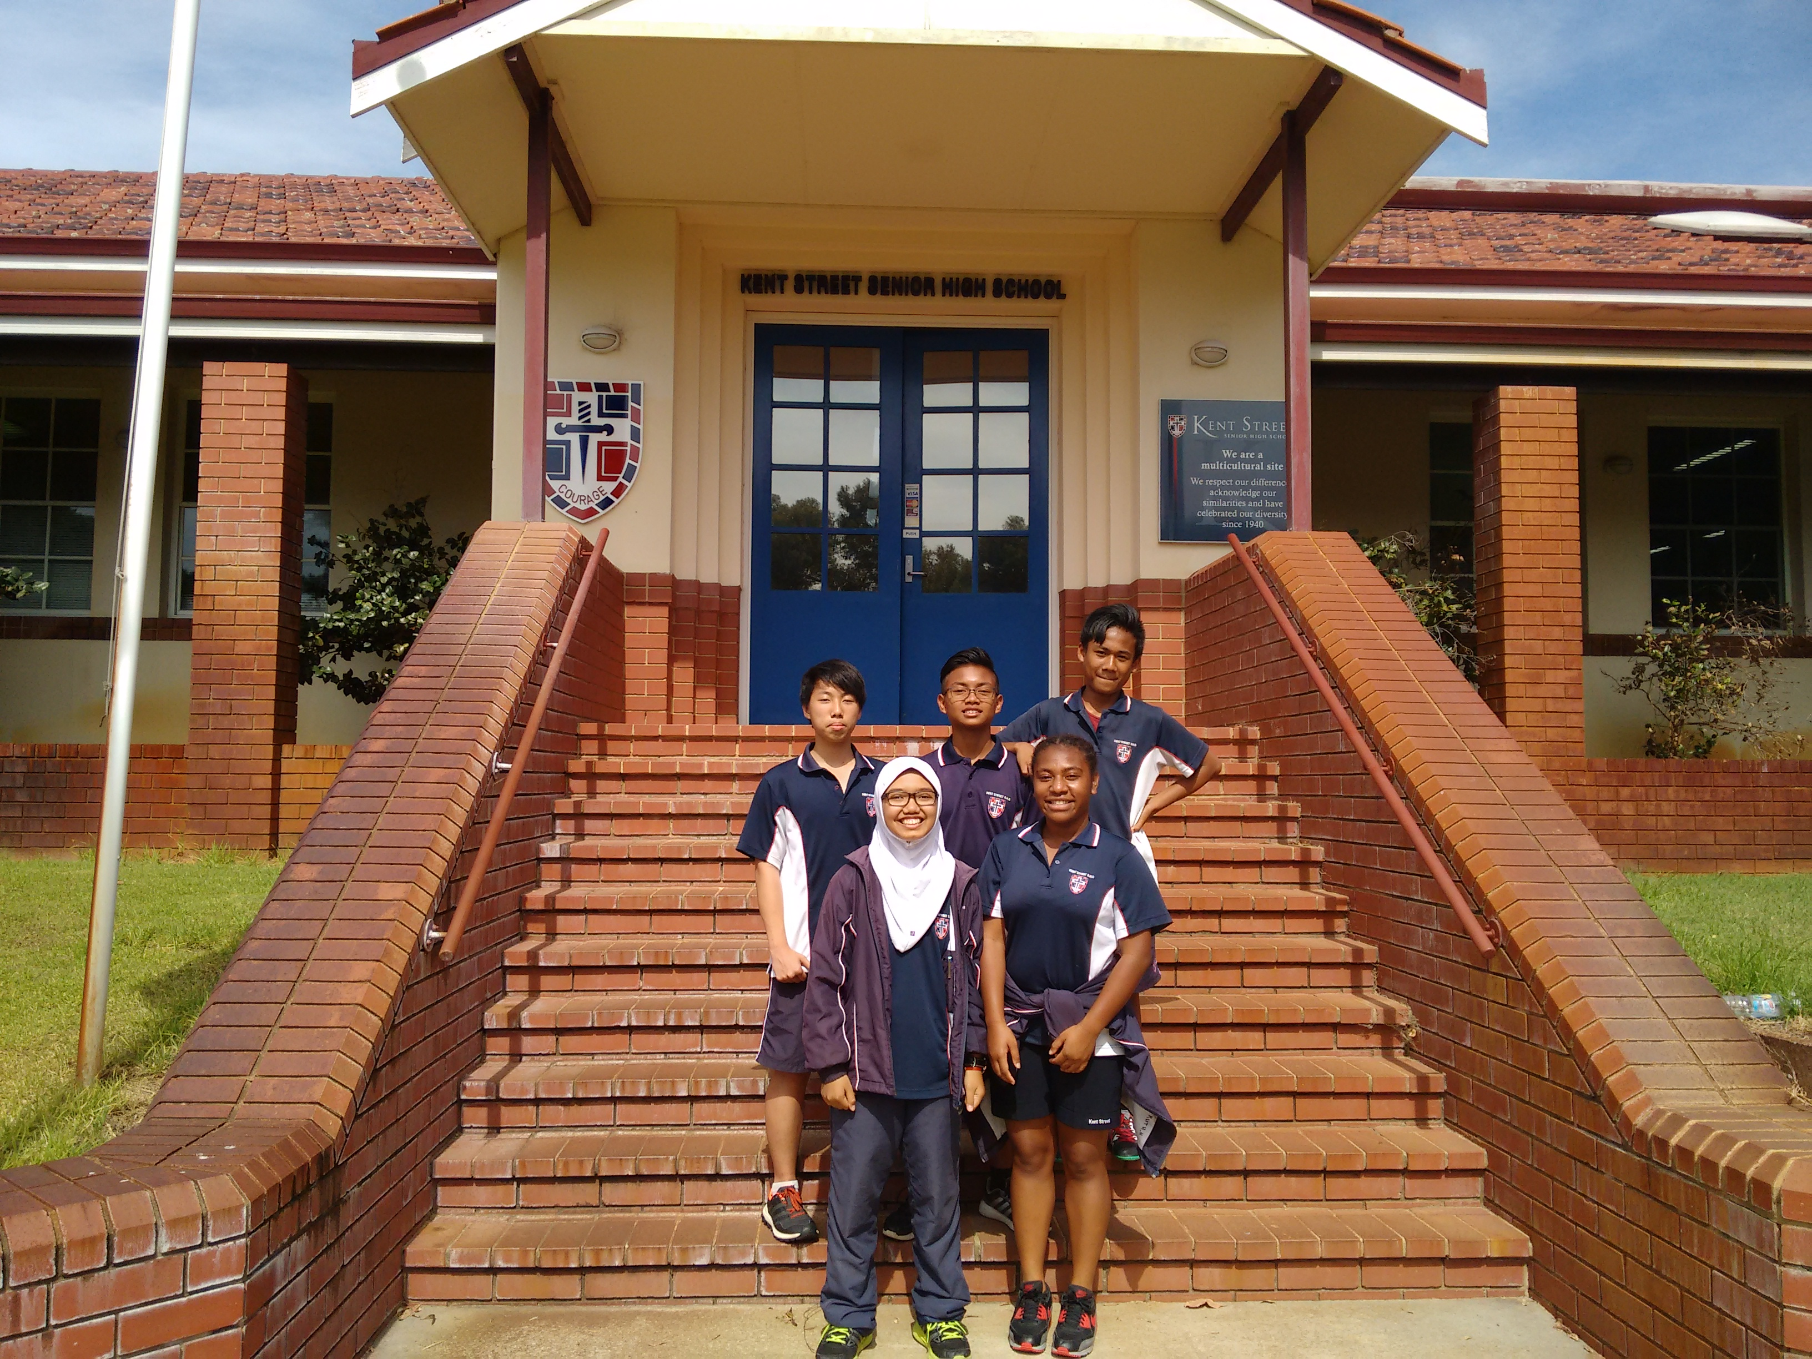  -Zahra Nur Salsabila- Ruth Henry-  -Muhammad Zain (Sheva)-  -Theddy A. Langsa- Kevin Richardson Tanjaya- |  | Name:_________  Date:___/___/___  BU leader :  Location:  - Hallway  - Library  - Classroom  - The oval  - Gym  Others specify: _______  HAZOB- A condition that has the potential to cause injury or damage.

Equipment Involved:  - Tables/Chairs  - Electronics  - Wires/Cables  - Chemicals  - Sharp Objects  - Power point  - Sink  Other (specify):  ____________________.  What happened:  ____________________  ____________________  ____________________  ___________________.  Potential Hazard:  High  Med  Low | - Chemical Hazard-  Harmful chemicals.  e.g. Flammable fumes  - Biological Hazard-  biological substances that pose a threat to the health of living organisms  e.g. Bacteria and virus  - Radiation Hazard-  The emission of radiant energy particle.  e.g. Boiling pan  - Sound Hazard-  Unwanted or damaging sound.  e.g. Noise equipment’s  - Gravity hazard-  Falling object due to gravitational pull.  e.g. Falling objects  - Motion Hazard-  Moving object that can hurt or kills us.  e.g. Vehicles  - Temperature Hazard-extreme temperatures. e.g. Steam |  | - Mechanical Hazard-refers to moving machinery e.g. Oven and toaster  - Electrical Hazard- Refers to an open circuit. e.g. Open wire and power line  - Pressure Hazard- Dangerous condition involving pressure. e.g. Gas turned on  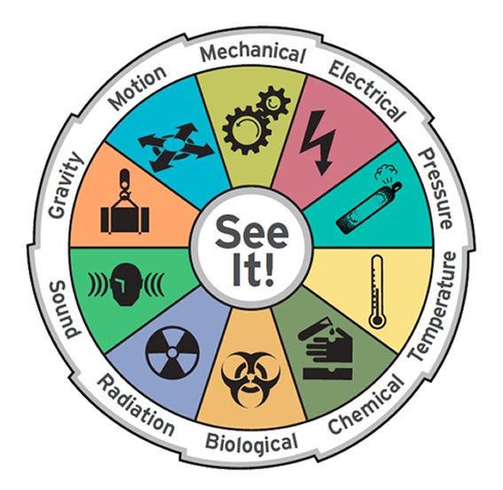  Hazard Wheel

